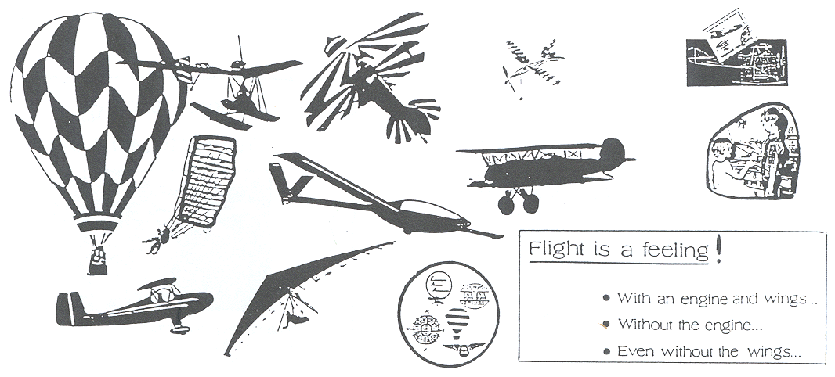
AIR SPORTS and MORE

MANY YOUNG PEOPLE ENTER THE WORLD OF AIR SPORTS
AS A RESULT OF A HOBBY RELATED TO AVIATION, A CLUB OR VISITING AN AIRFIELD.

INTEREST IN AVIATION IN ANY FORM BRINGS THE INDIVIDUAL INTO A VERY SPECIAL RELATIONSHIP WITH THOSE WHO MEET THE CHALLENGE OF FLIGHT THROUGH THE WORLD -

THE GOAL OF AVIATION EDUCATION IS TO PROVIDE AN INTRODUCTION TO THE BROAD SCOPE OF AVIATION AS A LEARNING EXPERIENCE.

THE CHOICE IS YOURS IF YOU WANT TO LEARN MORE AND BECOME INVOLVED WITH AIR SPORTS OR SOME OTHER PHASE OF AVIATION.

HERE IS A LISTING OF THE AIR SPORTS AND SOME OTHER ROBBY ACTIVITIES:

- AEROMODELLING
- GLIDING
- GENERAL AVIATION
- PARAGLIDING
- HANG GLIDING
- BALLOONS AND AIRSHIPS
- MICROLIGHTS
- AEROBATICS
- PARACHUTING
- HELICOPTERS
- COLLECTING
- PHOTOGRAPHY
- AVIATION CLUBS
- COMPUTER FLYING
- READING AVIATION PUBLICATIONS
- SCRAPBOOKS
- VISITS TO AIRFIELDS AND MUSEUMS
- HELP RESTORE AND ANTIQUE AIRPLANE

Often air sport pilots will invite a young person to look at their aircraft if they see a serious interest. Aiso, there may be an opportunity to work with the crew during practice sessions.

The place to start is to learn as much as you can about the fundamentals of flying and any air sport that interests you. Then visit the closest airfield and see if there is an aero club person to talk to.

THE AIR SPORTS
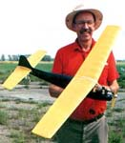
A Note About Aeromodelling:

Aeromodelling is perhaps the most common air sport for young people. It is suitable and challenging for all ages and is quite affordable.

The educational value of aeromodelling is very good. It encourages learning the basic fundamentals of aerodynamics which directly relates to the required knowledge of the other air sports.

Local contests are frequently organised by the clubs which adds to the pleasure of the sport. Championship contests become available as the individual becomes more skilled.


Hang Gliding
As hang gliders improve in performance and pilots learn more about micrometeorology, this young sport is developing fast and giving pilots the nearest thing to flying like birds.

Microlicht Aircraft
Some microlights (or ultralights) are controlled by weightshift—the simplest and cheapest—while others have mechanical controls with more performance potential.

Balloons
The oldest airsport. There are records and championships for gas and hot-air balloons. Growing in popularity in more and more countries as a peaceful and attractive way of flying.

Light Aircraft
Very active in aerobatics and precision flying, rallies and tours in company, and local and interconlinentol air races. Many new records are established every year for long distance or speed


Aeromodelting
Not only for the young. There ore 18 world championship classes, including those for radio controlled gliders and space models. Some events have as many as 300 competitors.

Helicopters
A steadily developing precisior flying sport, with emphasis on rescue and service to others
Homebuilt Aircraft
Thousands of enthusiasts build their own aircraft and fly them. Some also design them while others restore historic aircraft or build replicas.

Parachuting
A rapidly changing sport, parachutes are being developed with more controllability and sky divers work out new formations.


Gliders (Sailplanes)
A high technology sport. With wingspans of 25m (80 feet) and carrying 300 kg (660 Ibs.) of water ballast, today's singIe-seater sailpianes have glide angles of 1:55.

AIRFIELDS ARE INTERESTING AND NECESSARY !

In the early days of flying, aeroplanes landed in farm fields, on roads or where ever the pilot could find a fairly level open space.

Today’s airfield is the designated landing and take—off area the aeroplanes are required to use.

The airfield can be as simple as a narrow strip of grass—covered ground near a small village. It can also be a large complicated area with long concrete runways and many specialised buildings.

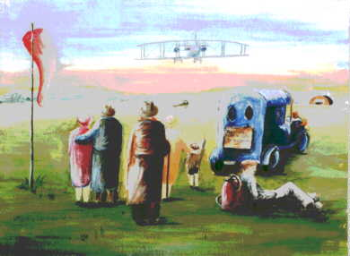
The kinds of aeroplanes that use the airfield is the determining factor as to the size and functions necessary for any particular airfield

Air traffic control is necessary at larger airfields using radio communications and radar. Smaller airfields have a prescribed flight pattern that the pilot must follow.

Most airfields have fuel available and hangars to protect the aeroplanes from the weather. Maintenance is another requirement as the government has strict rules as to how the aeroplane is cared for.

Large commercial airfields have terminal facilities to accommodate passengers travelling on the airlines. A restaurant is available as well as automotive parking. Fire and emergency vehicles are manned and ready.

Airfield security measures often discourage visitors to wander about by themselves. Most airfields, large or small are concerned about safety.

It is suggested that the manager or someone in authority be contacted to see if a tour can be arranged. Most are pleased to have someone or a school class visit, but it must be at a time mutually convenient.

Here are some questions to consider :

- Where is the airfield located?
- How did it get started?
- Who owns the airfield?
- What kind of aeroplanes use the airfield?
- What kind of jobs are there at the airfield?
- What are the benefits to the town from having the airfield close by?
- Would a tour of the airfield be possible?
- Are air sport events hosted there?

THE SPACE SHUTTLE

The Space Shuttle is a spacecraft that can be used for many flights into space. It carries people and experiments to Earth orbit. Scientists and engineers ride in the Shuttle and operate experiments in space. Someday, the Shuttle may carry you to Earth orbit.

The Space Shuttle has four major parts: The orbiter, the Solid Rocket Boosters (two), the External Tank, and the set of three Space Shuttle main engines in the rear of the orbiter. Only the orbiter and the main engines go into Earth orbit. The other parts are for liftoff and powered flight.

NASA’s Marshall Space Flight Center in Huntsville,
Alabama, provides the boosters, the External Tank, and the main engines for the Space Shuttle.
