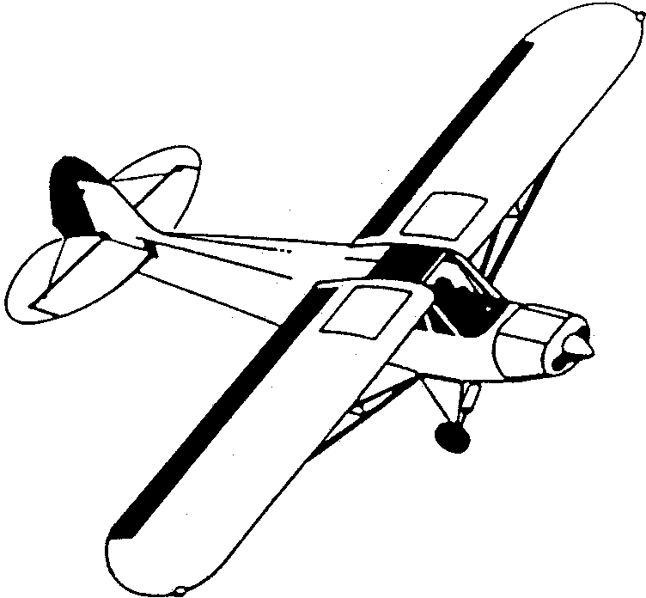



Know the freedom that pilots experience as they travel the limitless sky, near the stars. clouds, and winds that circle the earth!

FLYING IS FUN!

When a plane passes over, do you wish you could be flying high above the ground, soaring like a bird? You can be. You can know the freedom that pilots experience as they travel the limitless sky, near the stars, clouds, and winds that encircle the earth.

If you think that piloting a plane is only for those who joined the military or became commercial airline pilots, think again. You can be a part of general aviation.

The term general aviation refers to all aviation activity that is not military or commercial. Each year more than 100,000 people in the United States take lessons to learn how to fly general aviation aircraft. When asked they want to learn to fly, most say, “because flying is fun.”

Some of the people who learn to fly are salespeople who want to expand their business territories or doctors who need to reach patients in remote areas. Others fly for recreation, like going on vacation. Some people who learn to fly are teenagers getting a head start on a piloting career.

And not only is flying fun, but it’s also efficient. Many trips that normally take a whole day by car can be made in half the time, or less, in an aeroplane.

WHY DOES AN
AIRPLANE FLY?

Although nothing is mind-boggling or mysterious about flying, there is much to learn—just as there is in learning to drive a car. As you learn to fly step by step, you’ll find your training enjoyable and challenging.

Although aeroplanes have been a part of our society for more than 85 years, most people have only a vague idea of the basic principles of flight. Flight may seem complicated, but in fact it’s based on some simple laws of nature.

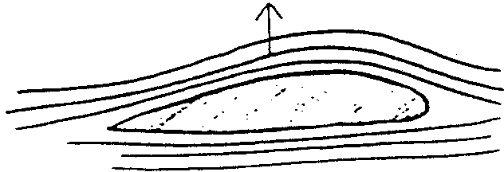
The principle of lift
When you examine a cross-section of an aeroplane’s wing, or airfoil, you’ll notice that the top part is curved and the bottom part is relatively flat. This special shape creates lift, which makes the aeroplane fly.

As the wing moves forward, the air flowing over the top travels faster than the air flowing beneath, resulting in a lower pressure area above the wing. The relative pressure differential provides the upward force called lift. Lift is basic to flying.

FLY - THE AEROPLANE EXPLAINED
WHAT ARE THE BASICS OF FLIGHT?

Lift and gravity
In order for an aeroplane to climb, lift must be greater than gravity, the force that holds objects on the earth.
For an aeroplane to maintain level flight at a particular altitude, lift and gravity must be the same, or in equilibrium. When gravity is greater than lift, the aeroplane will descend.
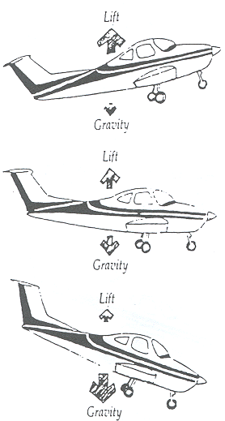
The parts of an aeroplane
An aeroplane, of course, is more than awing, a propeller, and an engine.
The body of the aeroplane, which holds the pilot, passengers, and baggage, is called the fuselage.
The tail of the aeroplane is called the empennage, and it consists of the horizontal and vertical surfaces called stabilisers. They create the stability necessary to use the lift and thrust created by the wing and the engine-driven propeller.
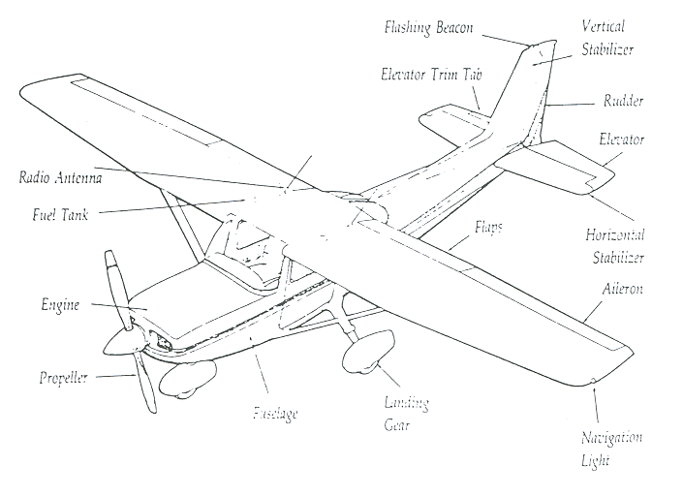
Parts of the wing, horizontal stabiliser, and vertical stabiliser are moveable to provide the pilot with the means to control the aeroplane. These control surfaces are called ailerons on the wings, elevators on the horizontal stabiliser, and rudder on the vertical stabiliser.
You’ll become as familiar with the workings of these different parts as you are with the operation of a car.

Thrust and drag
As an aeroplane moves forward, the wing produces lift. The force of forward movement is called thrust, and it’s created by the engine-driven propeller or a jet engine.

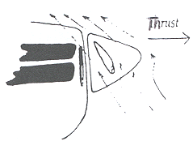
Like the wing, the propeller is also an airfoil. As it rotates, it creates “lift” in a forward direction that is called thrust. Thrust overcomes drag (resistance of an object toward movement).
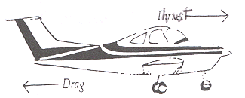
When thrust is greater than drag, during takeoff, for instance, the aeroplane’s speed increases. When thrust and drag are equal, the aeroplane maintains the same speed. Whenever drag is greater than thrust, the plane slows down.

Lift, gravity, thrust, and drag are the four forces acting upon the aeroplane. You’ll learn to understand them thoroughly as you advance in your study of flight.

Control
As the pilot, you control the aeroplane, and you determine how it flies. The different movements of your controls will cause corresponding movements in the aeroplane. Here are some basic aeroplane movements.
Pulling the control wheel toward you raises the elevator, which in turn forces the tail down and the nose up. This serves to create more lift than gravity and the aeroplane will climb. To help produce the extra lift needed in the climb, you usually need additional power from the engine, which you achieve by using the throttle control. Pushing the control wheel away from you lowers the elevator, forcing the tail up and the nose down. This reduces the lift, and gravity makes you descend.
The rudder pedals control the movement of the plane from right to left in much the same way as the rudder of a boat. Pushing the right rudder pedal forces the nose of the aeroplane to the right, and the left rudder pedal produces the same movement to the left:
Turning the control wheel moves the ailerons in opposite directions, enabling you to raise or lower either the right or left wing, which enables the aeroplane to turn faster than using only the rudder.
To change the attitude of the aeroplane, its relationship to the horizon, you simply use the control surfaces and the power of the aeroplane. It’s an exercise in co-ordination, much like riding a bicycle. Your Right instructor will discuss with you how these simple movements can be combined to manoeuvre the aeroplane.

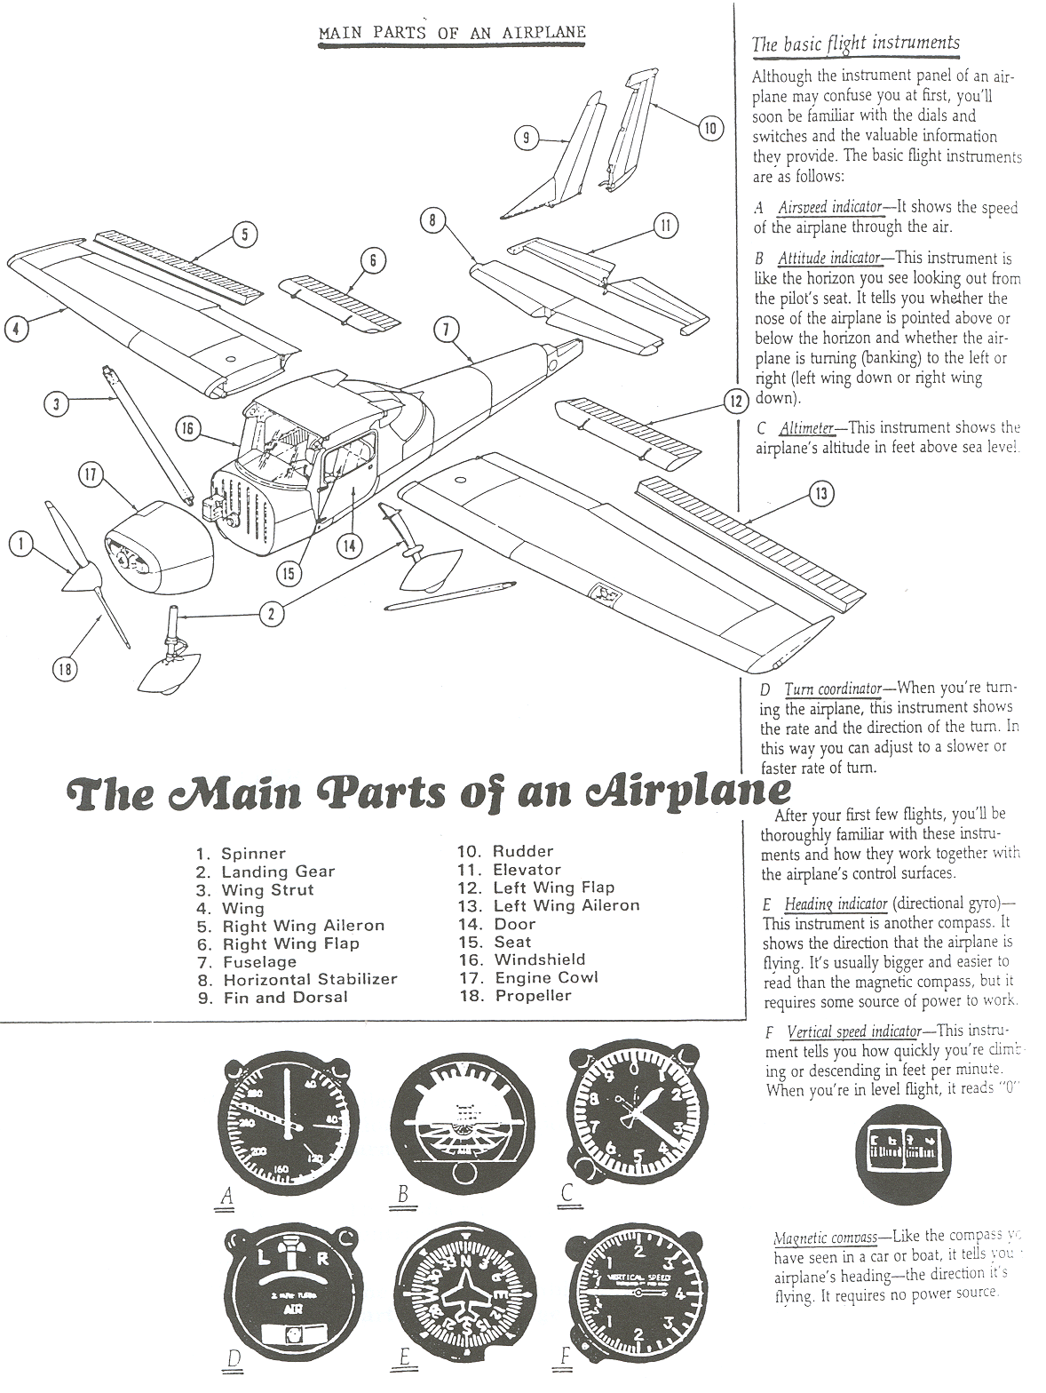

MAIN PARTS OF AN AEROPLANE

THE DEFINITIONS LISTED BELOW ARE COMMON
TO MOST ALL AEROPLANES. THIS IS ALSO THE
CASE FOR THE INSTRUMENTS DESCRIBED ON
THE PREVIOUS PAGE.

AIRPLANE - An airplane is a vehicle heavier than air, powered by an engine, which travels through the air by the reaction of air passing over its wings.

FUSELAGE - The fuselage is the central body portion of an airplane designed to accommodate the crew and the passengers or cargo.

COCKPIT - In general aviation airplanes the cockpit is usually the space in the fuselage for the pilot and passengers; in some aircraft it is just the pilot’s compartment.
LANDING
GEAR - A landing gear is underneath the airplane and supports it while on the ground.

PROPELLER - A propeller is a rotating blade on the front of the airplane. The engine turns the propeller which pulls the airplane through the air.

WINGS - Wings are parts of airplanes which provide lift and support the entire weight of the aircraft and its contents while in flight.

FLAPS - Flaps are movable sections of an airplane wing closest to the fuselage. They both move in the same direction (down) and enable the airplane to fly more slowly.

AILERONS - Ailerons are outward movable sections of an airplane wing which move in opposite directions. They are used in making turns.

RUDDER - The rudder is the movable vertical section of the tail which controls lateral movement.

HORIZONTAL
STABILIZER - The horizontal stabilizer is the horizontal surface of the aft part of the fuselage used to balance the airplane.

ELEVATOR - The elevator is the movable horizontal section of the tail which causes the plane to move up and down.

AIRCRAFT CATEGORIES

There are many kinds of aircraft today that are used in many different ways.
Here are a few common categories to start with:

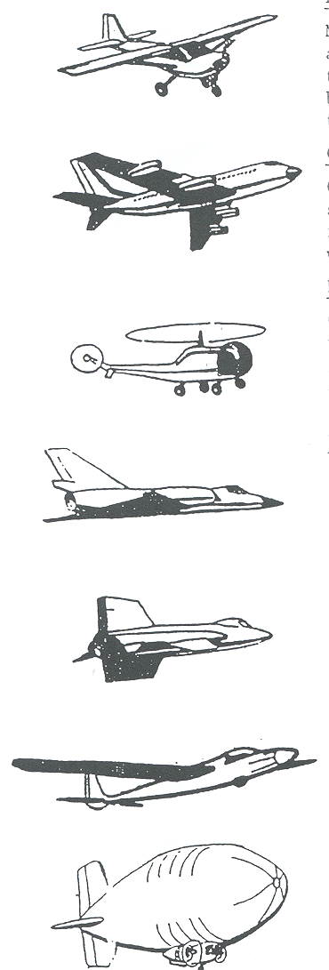
PERSONAL AND BUSINESS

Most common type seen at your airport. Often can be compared to family automobile. There are business jets that also fit into this category.

COMMERICAL AIRLINERS

Carry large numbers of passengers safely from city to city and even from country to country around the world.

HELICOPTERS

Can take—off and land in very small places. Sometimes called “Steep gradient” aircraft. New designs are able to fly almost as fast as an aeroplane.

MILITARY AIRCRAFT

Both very high performance fighters and other special purpose aircraft are needed. Many other aircraft like those in the other categories are also used.

EXPERIMENTAL

Very special aircraft used to discover new knowledge about flight. Also to test new aircraft designs.

GLIDERS

They are without engines and must be towed into the air by another aeroplane. Once free, they soar like birds using the upward air currents to stay up.

LIGHTER THAN AIR

Balloons and blimps float like corks in water. Some use a light gas and others depend upon heating the air inside for the lift force.

1. How many types of aircraft have you seen?

2. What are the advantages of air travel?

3. Can you think of other ways aircraft are used?

4. If you were a pilot, what kind of aircraft would you want to fly? Why?

