THE REALM OF FLIGHT

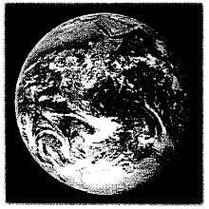
Outside
If you were in space, you would see the earth as a blue and brown ball covered by swirling masses of clouds. The earth is not a perfect sphere, however. It is bigger around the equator than it is around the poles and it also bulges out very slightly below the equator, giving it a shape more like a pear than a sphere.

Diameter at equator: 7.926 miles (12.756km)
Diameter at poles: 7,900 miles (12,714 kin)
Circumference at equator: 24.902 miles (40.075 kin)
Mass: 6,600.000,000,000,000,000,000 (6.6 sextillion) tons (6.0 sextillion metric tons)

Clouds float in a layer of air that surrounds the earth. This layer, called the atmosphere, contains mostly nitrogen and oxygen gases. The atmosphere shields the earth from harmful rays coming from the sun. It also keeps the earth from becoming too hot or too cold.

Land covers about 29% of the earth’s surface. Most of the land is broken into large pieces called continents. Smaller pieces of land are called islands. The tallest point of land on earth is the peak of Mount Everest, 29,028 feet (8,848 metres) above sea level.

About 71% of the earth’s surface is covered with water. The deepest water is in the Mariana Trench in the Pacific Ocean, where the water measures 36,198 feet (11,033 in). Water helps keep the earth at a temperature that can support life.

THE REALM OF FLIGHT
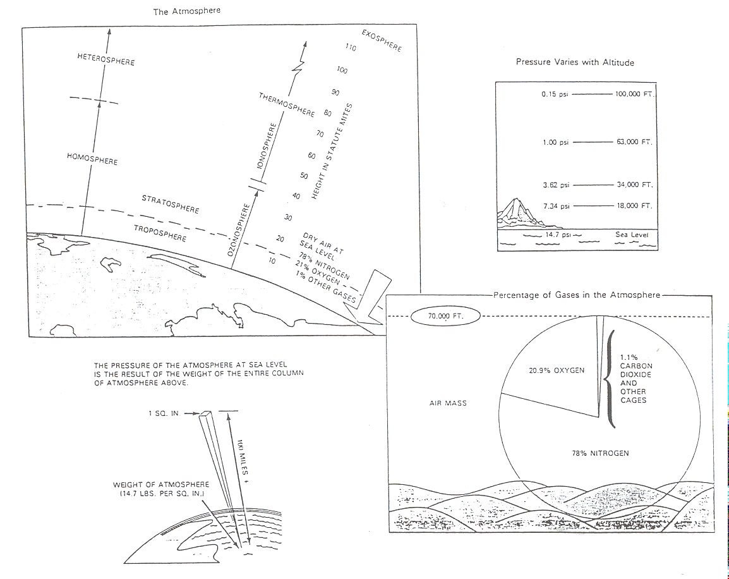
Exercise: Demonstrating to students effects of gravity.
Materials: Two pieces of equal size paper.

Directions: Have students crumble one piece of paper, have them then stand up, and hold the crumbled sheet in one hand and fiat piece of paper in the other. Ask the students which one would hit the floor .first If the papers were dropped from equal heights? Allow time for students to predict the outcome and then have them all drop their papers simultaneously. Ask students to explain why the crumpled paper took less time to fall, (fight the force of gravity,) even though both pieces of paper weighed the same amount. (Answer: The crumpled piece of paper had less surface area to resist the push of air aside as it fell; thus, it fell more slowly. (This is the same principle utilised by parachutes.)

THE ERAS LEADING TO
GLOBAL AIR TRANSPORTATION

BEFORE POWERED FLIGHT Mythology & Legends
The Visionaries
Lighter—than—Air Success

EMERGENCE OF FLYING MACHINES The experimenters
Wright Brothers Saga
Competitive Relationships

PRELUDE TO WWI AND THE
FORMATIVE ERA OF THE. 192Os Exhibitions & Pro-motional Events
Airships—The Alternative
A New Industry Develops.
Heroes And Public Awareness
Airmail & Government Regulation
Creation Of Airfields
SURVIVAL DURING THE
TURBULENT 1930's More Government
Growth Of Airline Service & The
Need For Airports
Contributing Role Air Racing/Feats
Death Of Airship Travel

THE “AIR AGE” ARRIVES AS A
LEGACY OF ANOTHER WORLD WAR Wartime Achievements
Jet Power & A New Realm Of flight
Growth Of Private Air Transportation
Helicopters Struggle For Their Role
More Government

GLOBAL TRANSPORTATION IN
THE JET AGE Access To GIobal Transportation System
Space Program Spin-Offs
Social-Economic & Geopolitical Impacts
Airports and Public Concerns

LOOKING INTO THE 21st CENTURY Next Generation: Supersonic & Hypersonic Air Transportation
Intermodal Transportation Centres

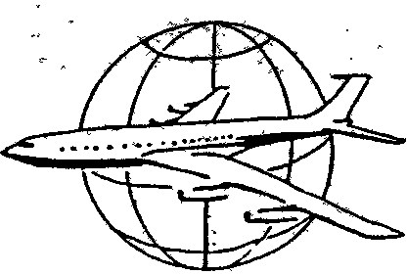

THE HERITAGE OF FLIGHT

To many people in today's world, flight has become commonplace and seemingly very natural. They board today’s flying carpets (jet airliners) and are whisked across the countryside at speeds considered impossible less than 100 years ago.

Modern air travellers seldom have thought about mankind’s centuries—long struggle to fly or perhaps have passed it off as something unimportant.

Mankind’s ability to fly was accomplished only by years of trial and error, success and failure. Many natural laws needed to be overcome.

Many hundreds of skilled and dedicated men and women have slowly, step—by—step, built the base upon which our present day aviation is working.

These individuals came from different nations and varied backgrounds, but they all had one thing in common the imagination to look into the future and the genius to mould their ideas into a reality.

This heritage has led us into today’s aerospace world which is the prelude to tomorrow’s even greater advances in our global society.

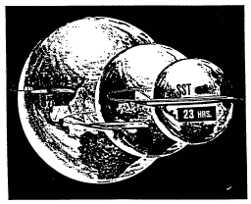

The Shrinking World

To Circle The World

1954 - - - - - - 87 hours
1960 - - - - - - 44 hours
1990 - - - - - - 23 hours (SST)
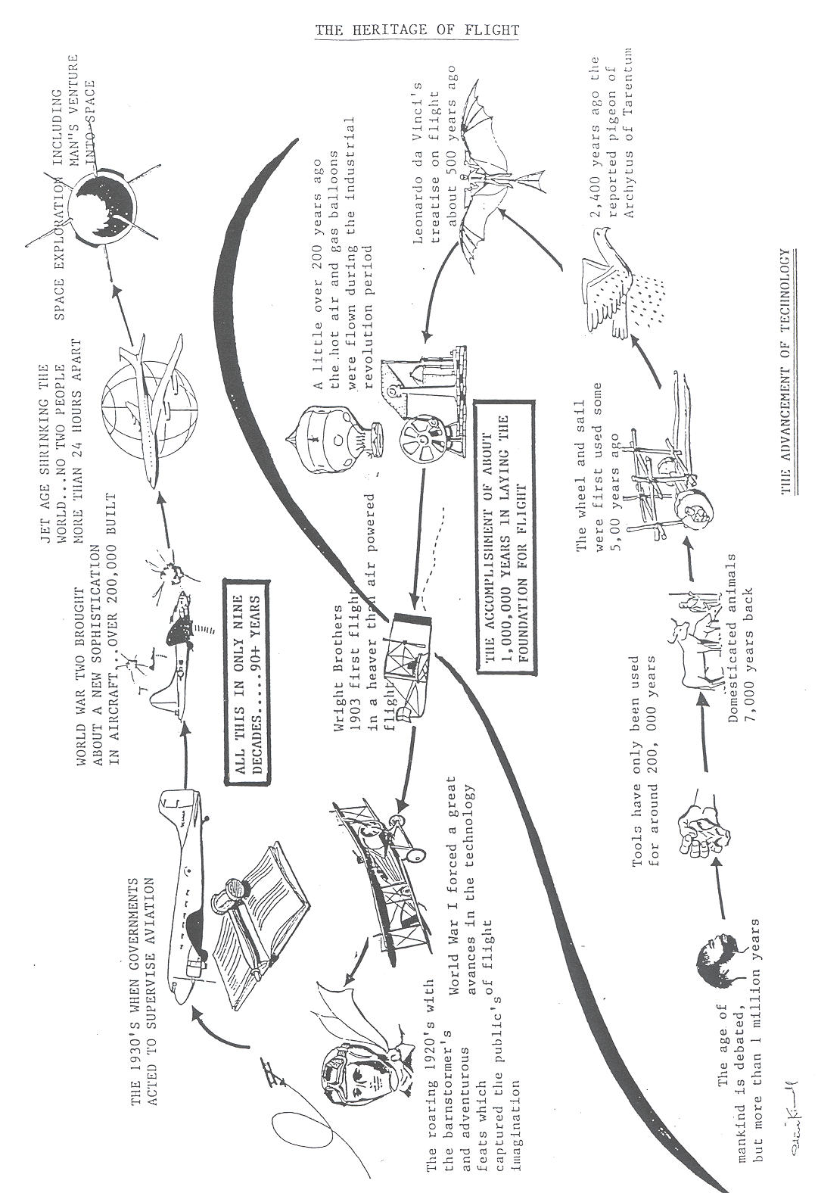
Heritage…..

